Ben Diflo
Eugene Han
Arch 243
4/4/21
Agent 3 Paper

In the fabric of the Kips Bay neighborhood in Manhattan, we will be following a food truck employee. My day does not start in Manhattan, but in Queens. I wake up early, before the sun is up, and get ready for the day. I have been doing this same routine for 14 years. It is hard work, but it is honest and a good job. I make my way to the garage where many other food trucks are parked. Mexican, Halal, Jamaican, breakfast, whatever you can think of, there is probably a food truck for it. I make sure I have all of the ingredients or the day, hook the cart up to my truck, and start making my way into the city. I usually take the Queensboro bridge, which drops me off in midtown. The tunnel brings me closer, but it costs a fare. Once across the bridge, I get on the FDR and go down to my usual spot between 32nd and 33rd street on first avenue. The morning air is crisp, and looking across the east river to Brooklyn the sun gently rises. The highway elevates at certain points, creating beautiful perspectives of the city and river (Formal/Typographic). I am able to dodge the morning rush that usually backs up the FDR, but there are still plenty of cars. I see a handful of trucks pulling their own food trucks, to disperse across all of Manhattan.
The cart is something of a mobile commands center, like an office on wheels. When the weather is nice, it is very enjoyable being outside for much of the day. The cart provide shade, but it is a thin barrier between inside and outside. It is also somewhat of a stage, an elevated platform with windows that allow the customer to look in and see what is going on. The food is prepared right in front of them, on a flat griddle. People love to watch their food being prepared, and it creates more of an interactive experience. As I cook, I ask them what toppings they want, and to kill the time, maybe make some small talk. When they pay, they are paying for both the product and the service.
With rent prices so high in the city, it makes sense to own a cart. No rent needs to be paid, but the cart must be maintained and certifications must be kept up to date. There is a sense of freedom that I am not stuck in one particular area, and can freely choose where I would like to work whenever. I have worked all over the city: midtown, downtown, but Kips Bay is my favorite neighborhood. Out of my 14 years of working on this cart, I have spent the most of my time here (Rhythmic/Arhythmic). The area is generally pretty quiet, full of nice, friendly people. I have many regular customers who I see frequently, which makes the job so much better. Having those small connections and conversations are enough to brighten up your whole day. I situate myself across the street from Hospital row, a row of about half a mile consisting of mostly NYU medical buildings, and many workers at the hospital come get their lunch from me. I am smushed right between the outer wall of the Kips Bay Towers Complex and the bike lane of first avenue. For normal standards, the area is pretty busy, but for Manhattan it is definitely pretty quiet. Bikers wiz past behind me, and pedestrians stroll by in front. The sense of urgency that plagues midtown is not as apparent here, people take their time. This urgency does manifest in the ambulances, however, which fly down the road squealing at all hours of the day. But again, after 14 years, I barely even notice anymore. Other than that, this area is just right, away from much of the madness of the city. It is more residential, less corporate, less busy, and quieter. The towering structures block out some of the sun, but by midday it is very bright out. The heat in the summer can get pretty brutal, because 90 degrees feels a lot hotter when you are in a metal box full of stoves. It is manageable, however, since New York gets all of the seasons, so it is rarely extremely hot or cold.
I serve the basic halal food that is famous around New York City: chicken and lamb gyros and platters. Sometimes we have fish, burgers, hot dogs, or philly cheese steaks, However, the vast majority of people come for a gyro or a platter. People love the food, so I have kept my recipe the same for a long time. I have been on this block for so long, and I have seen countless other carts come and go, Some of my customers ask me what I think about these other guys, but I do not worry about it. I have enough customers who I know will keep coming back for halal food. I have also kept my prices the same for years, something that is very uncommon across the city. Depending on the location, some carts will charge up to $9.00 for a chicken gyro in Manhattan, but I have kept my price at $5.00. Good service, good prices, and good food is the only way to ensure customers keep coming back, and since I don’t need to pay rent for a spot in the city, I don’t need to continuously increase my prices. Avoiding this is huge, because it is the death of most food establishments in the city (Solitary/Connected). Rent prices continue to fill the NYC bubble, and it is getting to the point where many successful businesses cannot keep up with the prices. Especially after COVID, many of us food workers are having a very tough time, as we were out of work for while. Food carts did not get a lot of work over the past year, and it has been very difficult for food cart workers. Many of us are immigrants and are not provided with financial assistance or health insurance.
Though Kips Bay is a nice, quiet area, the homeless population in all of the city continues to increase. It is sad to see people suffering when they cannot find a job, so I try to help people where I can. The Men’s Shelter down the street provides places for struggling men to sleep at night, and during the day the shelter is closed. Many of these men are left to wander the streets during the day, unsure of what to do. Since I have kept my prices low, it can be difficult to make a good return on investment. However, my customers always come back, so I can afford to give out some food when someone asks for it.
This neighborhood has changed a lot since I first started working here. It seems like there is always some kind of construction going on (Diachronic/Synchronic). There is always either a new high rise development going up, a new section of NYU being renovated, or pipes under the street being dug up and fixed. At my spot on the corner, I am fully surrounded by layers of infrastructure. The only ounce of nature that I can find is in the people and pigeons that walk by, or by looking up at the sky. Looking forward there are only buildings, traffic signs, streets, cars, and bikes. The roads are a bit torn up, but not in a “run down” sort of way. You can tell it gets heavy use day in and day out. Massive concrete and metallic facades soar high above, and sit next to quaint residential townhouses (Object/Texture). These townhouses have been here for very long, some of them about a hundred years. They look old, but have a warm, homey character to them. A few food establishments dot the streets past 33rd, along with a bunch of other carts. 34th street is a larger intersection with more people, but between 32nd and 33rd is more relaxed.
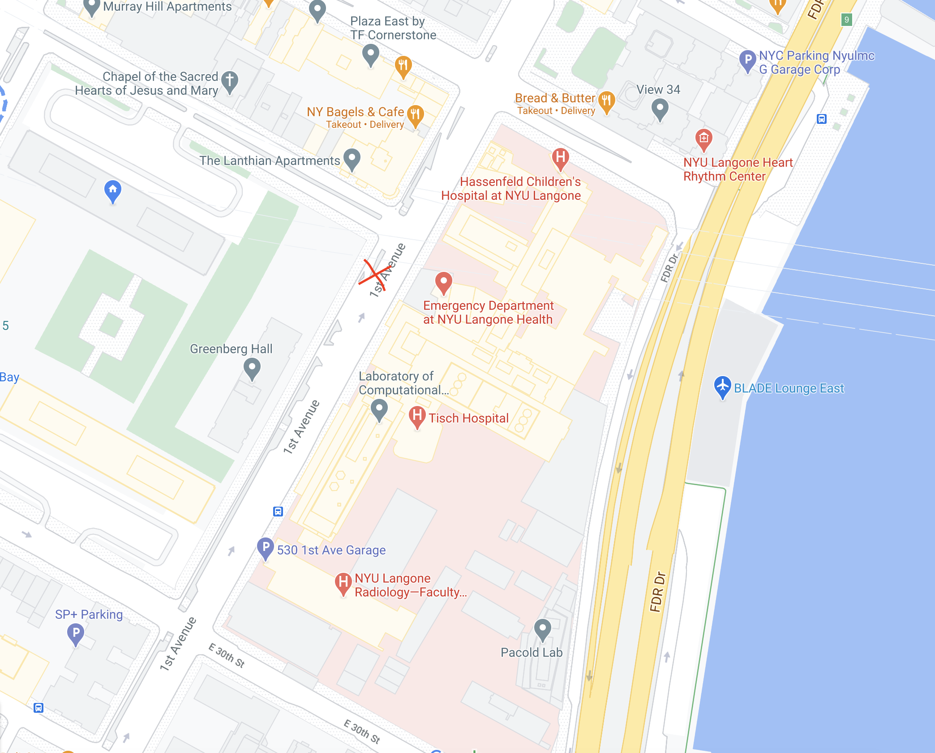
My day is busiest during the lunch rush, which is usually from around 11-1. Sometimes I will get another spike around 3:30, but usually lunch time is the busiest. The rest of the day is pretty easy, with customers coming here and there, but no stressful line down the street. By around 4 o’clock I have usually run out of chicken and lamb, and it is time to pack up for the day. I must clean the stoves, get rid of any trash, and hook up the cart to my truck, where I will bring it back to the garage. Once I get home, I need to marinate the chicken in a middle eastern yogurt blend for the next day. It is hard work, but it pays the bills, and I am happy with my life in NYC. I interact with nice people all day, and I am able to put my kid through school.

